***RETAIL SALES DATA ANALYSIS***

***Introduction***

The **Retail Sales Data Analysis** project aims to delve into transactional data from a retail environment to extract meaningful insights and patterns. This project emphasizes analyzing sales trends, customer demographics, and product preferences while identifying factors driving revenue. The dataset comprises transaction details, including customer information, product categories, sales amounts, and transaction dates. By leveraging Python for data analysis and visualization, this project showcases how data can inform business decisions, enhance customer understanding, and optimize product offerings.

***Objectives***

1. **Understand Sales Trends**: Identify patterns in sales over time to pinpoint peak periods and potential growth opportunities.
2. **Customer Segmentation**: Analyze customer demographics, such as age and gender, to uncover purchasing behaviors.
3. **Product Analysis**: Evaluate sales performance across product categories to understand product popularity and revenue contributors.
4. **Actionable Insights**: Provide strategic recommendations for improving business efficiency and customer satisfaction through data-driven decisions.

***[CODING]***

Step 1) Importing Libraries and Reading dataset

Step 2) Convert the 'Date' column to datetime format

Step 3) Check for duplicates and drop them if necessary

Step 4) Summary statistics for numeric columns

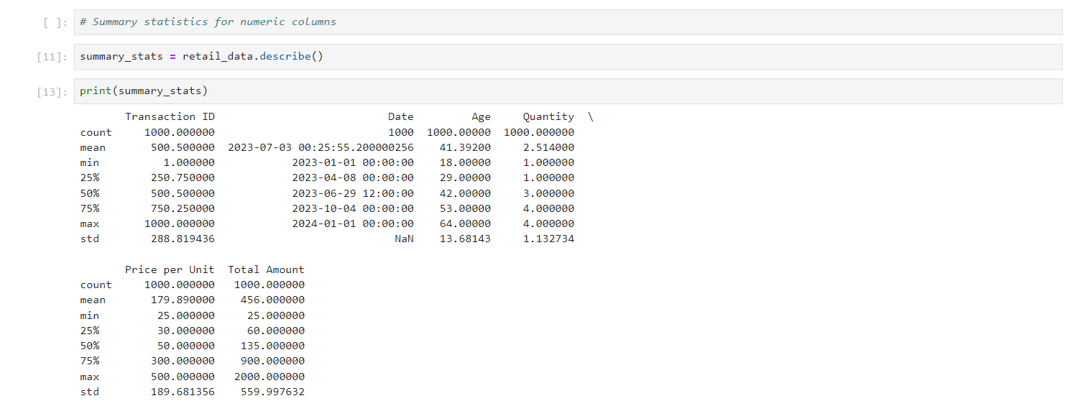

Step 5) Display cleaned data info and summary statistics



Step 7) New Cleaned Dataset

***EDA (Exploratory Data Analysis)***

***[Analyze sales trends over time.]***

***Visualisation (Using Power BI)***

1. COLUMN CHART

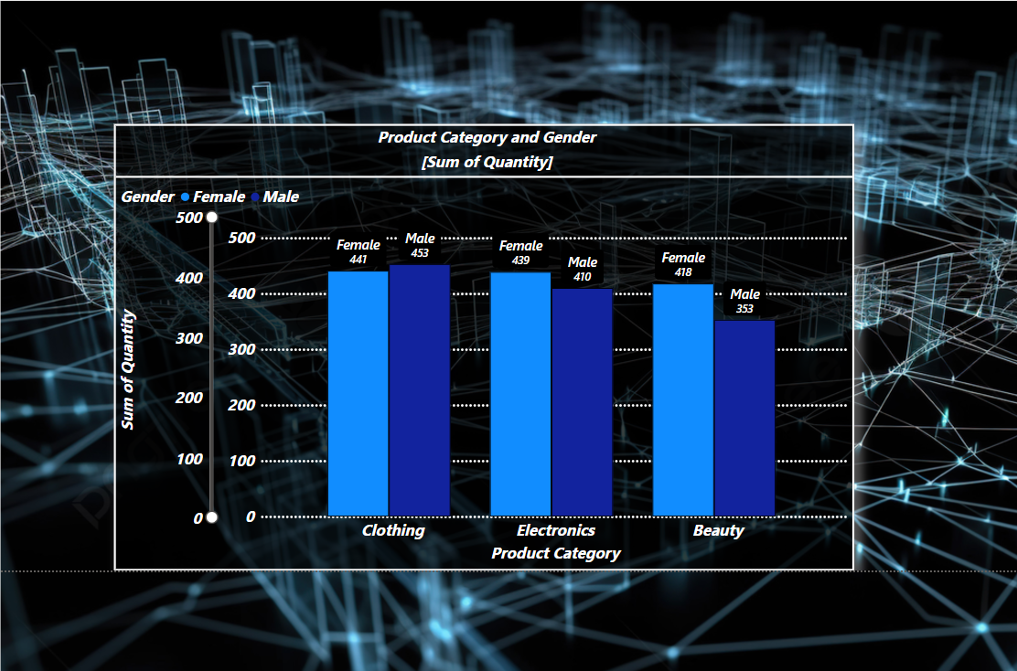

1. PIE CHART

1. DONUT CHART

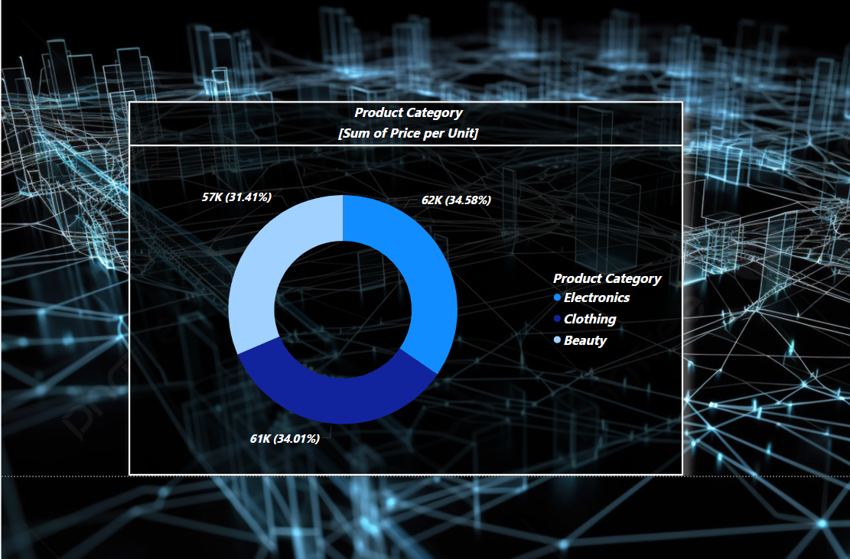

1. AREA CHART

***CASE STUDY***

1. **Data Preparation**: The raw dataset was cleaned by converting the Date column to a suitable datetime format, removing duplicates, and validating the completeness of the data. Summary statistics provided an overview of sales metrics such as total amounts, unit prices, and customer demographics.
2. **Exploratory Data Analysis (EDA)**: Visualizations like bar charts, pie charts, and scatter plots were used to:
   * Identify the highest-grossing product categories and their contributions to revenue.
   * Explore sales distribution by customer gender, revealing purchasing trends.
   * Examine customer spending behavior across different age groups.
3. **Insights**:
   * **Product Trends**: Certain categories, such as "Electronics" or "Clothing," contributed significantly to total sales, highlighting their importance in inventory planning.
   * **Demographic Insights**: Gender and age analyses provided a basis for tailored marketing strategies to target specific segments.
   * **Customer Prioritization**: High-value customers were identified, emphasizing opportunities for loyalty programs or premium services.
4. **Outcome and Recommendations**: This analysis equipped stakeholders with actionable insights to optimize product placement, enhance customer engagement strategies, and forecast demand more effectively. The visualizations added clarity, making the findings accessible and impactful for decision-makers.